DIS-AM,C-Taino-Puerto Rico-Pottery Bowl

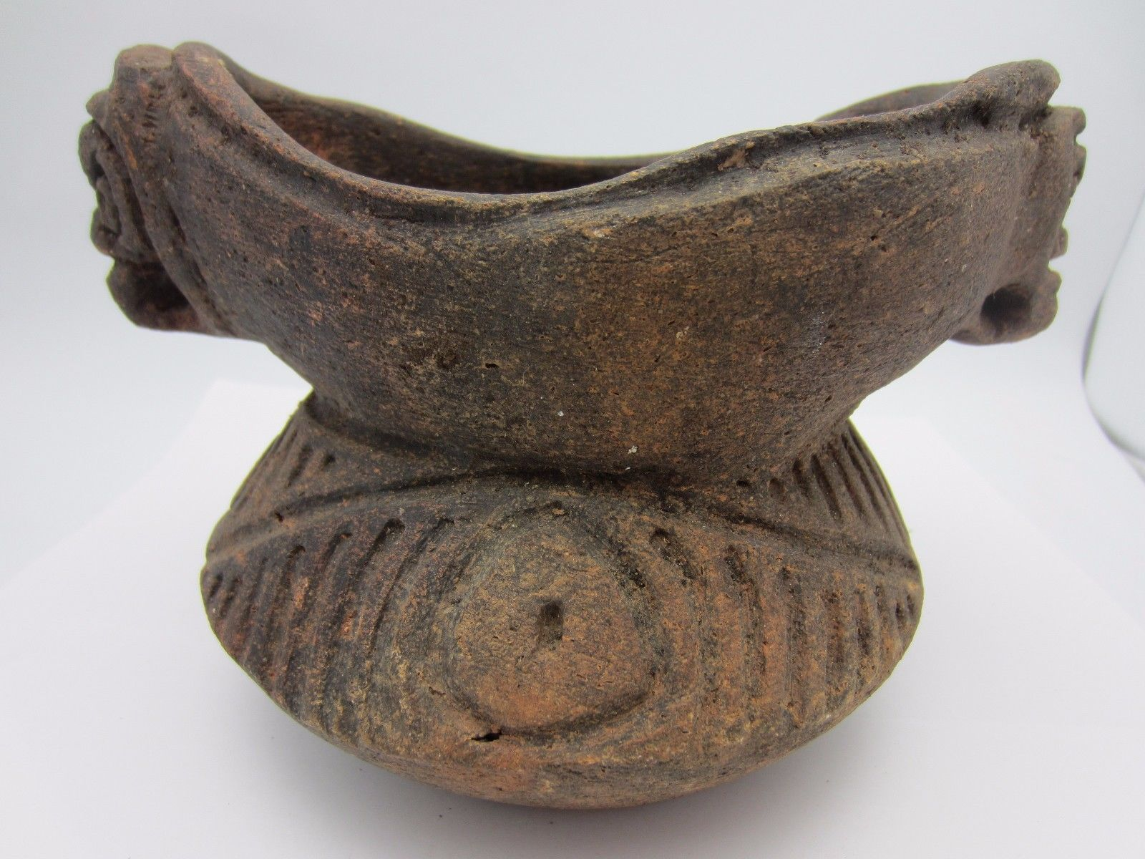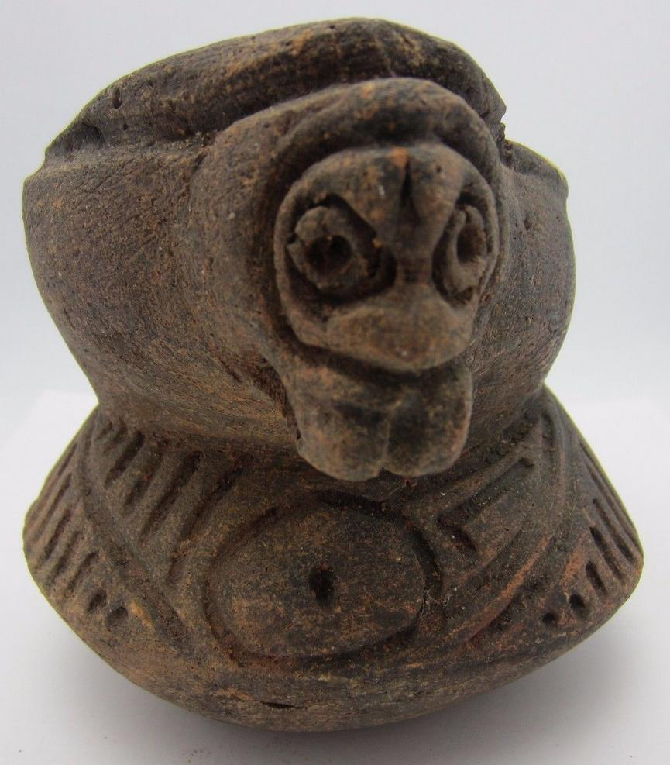 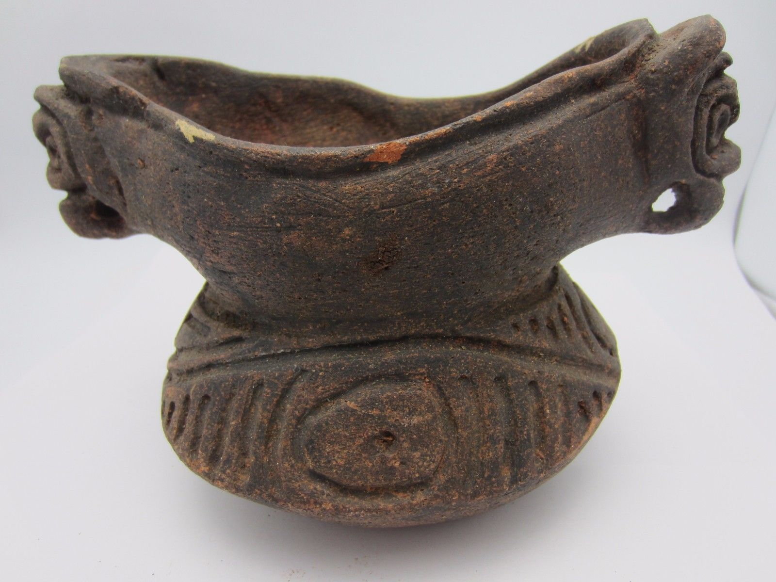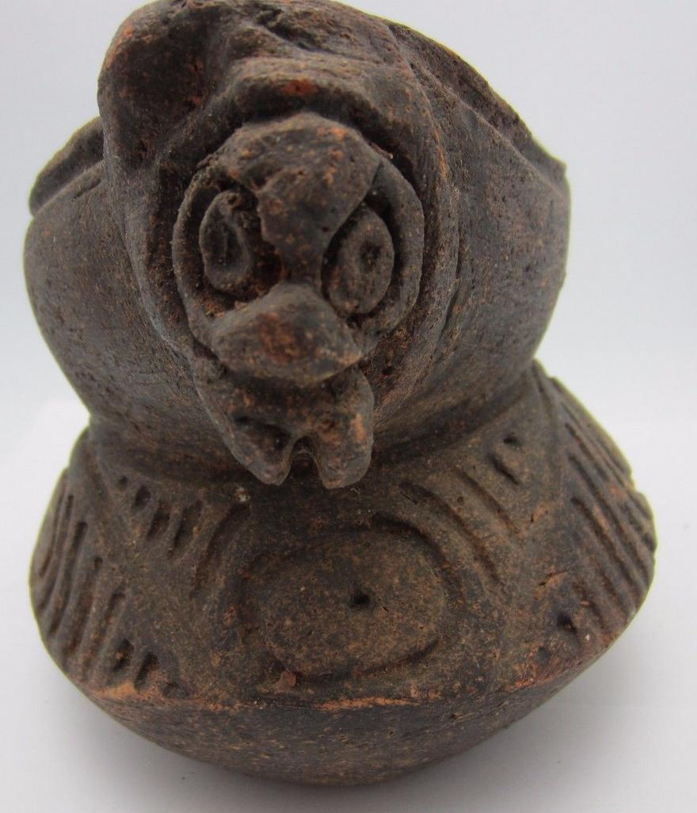

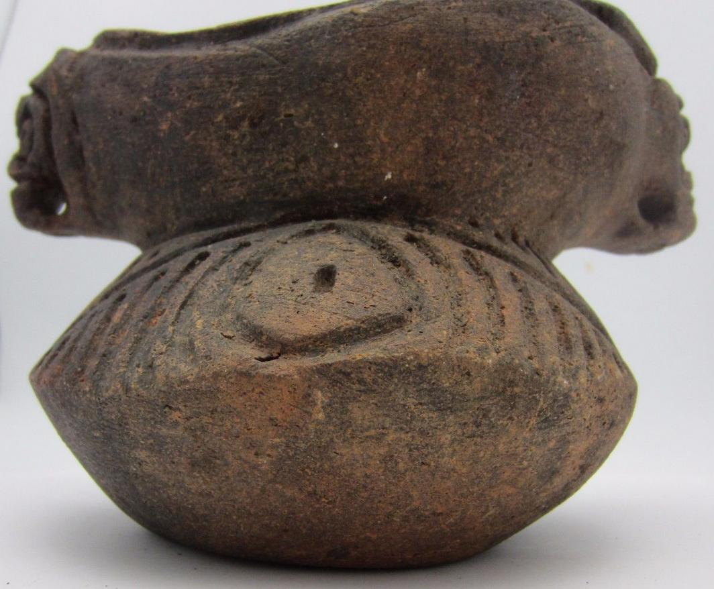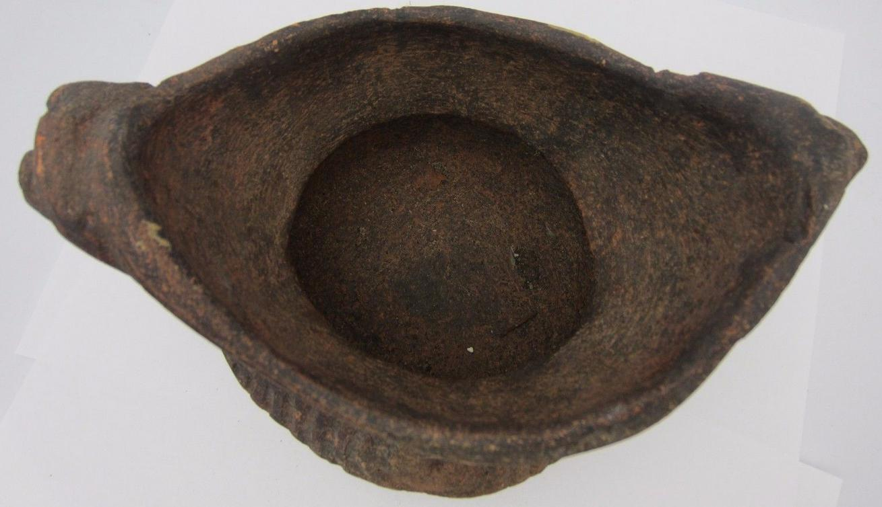

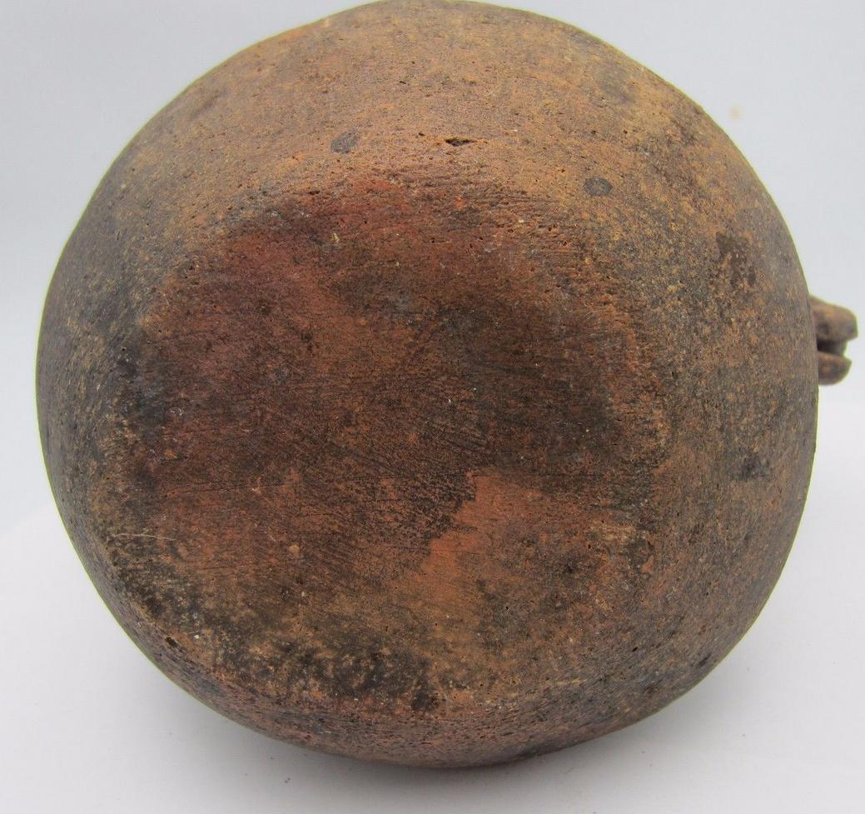

Sold by [schaferjewelers](http://myworld.ebay.com/schaferjewelers) ( [3483](http://feedback.ebay.com/ws/eBayISAPI.dll?ViewFeedback&userid=schaferjewelers) )

### Delivery package 1 of 1

Estimated delivery Thursday, Mar 17, 2016 - Monday, Mar 21, 2016

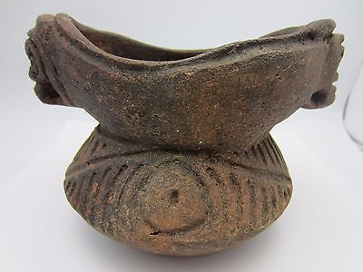

#### [Taino pottery bowl terracotta decorative art sculpture vessel Puerto Rico 7.5 in](http://www.ebay.com/itm/191826952291)

|  |  |
| --- | --- |
| Item price | $125.00 |
| Quantity | 1 |
| Item number | 191826952291 |
| Shipping service | USPS Priority Mail |

## Shipping address

Ralph J Coffman Jr

149 Atlantic Ave

Swampscott MA 01907-2427

United States

## Order total

|  |  |
| --- | --- |
| Subtotal | $125.00 |
| Shipping | $12.00 |

**Total**

$137.00

Order placed on

Tuesday, Mar 15, 2016

Payment method

PayPal

Payment date

Tuesday, Mar 15, 2016